***HARISH.K***

***727722EUIT505***

***ADD TO CART:***

***package com_success_test2.travel;***

import org.openqa.selenium.By;

import org.openqa.selenium.WebDriver;

import org.openqa.selenium.chrome.ChromeDriver;

import org.openqa.selenium.chrome.ChromeOptions;

import io.github.bonigarcia.wdm.WebDriverManager;

public class CA1 {

public static void main(String[] args) {

// **TODO** Auto-generated method stub

WebDriverManager.*chromedriver*().setup();

ChromeOptions co = new ChromeOptions();

co.addArguments("--remote-allow-origins=*");

WebDriver driver = new ChromeDriver(co);

driver.manage().window().maximize();

driver.get("https://www.amazon.in/DR-VAKU-Adapter-Charger-Black/dp/B09KN43PW1/ref=sr_1_1_sspa?crid=3GMJKRSPW2K0J&keywords=iphone+charger&qid=1681291277&sprefix=ip+hone+c%2Caps%2C432&sr=8-1-spons&sp_csd=d2lkZ2V0TmFtZT1zcF9hdGY&psc=1");

driver.findElement(By.*id*("add-to-cart-button")).submit();

String t = driver.getTitle();

System.***out***.println(t);

// Click on Cart Icon

driver.findElement(By.*id*("nav-cart-count-container")).click();

// Verify Item is in Cart

String cartTitle = driver.getTitle();

if (cartTitle.equals("Amazon.in Shopping Cart")) {

System.***out***.println("Item is in the Cart");

// Click on "Delete" button to remove the item from cart

driver.findElement(By.*cssSelector*("[value='Delete']")).click();

// Verify if the item has been removed from the cart

String emptyCartTitle = driver.getTitle();

if (emptyCartTitle.equals("Amazon.in Shopping Cart")) {

System.***out***.println("Item is NOT removed from the Cart");

} else {

System.***out***.println("Item is removed from the Cart");

}

} else {

System.***out***.println("Item is NOT in the Cart");

}

}

}

***OUTPUT:***

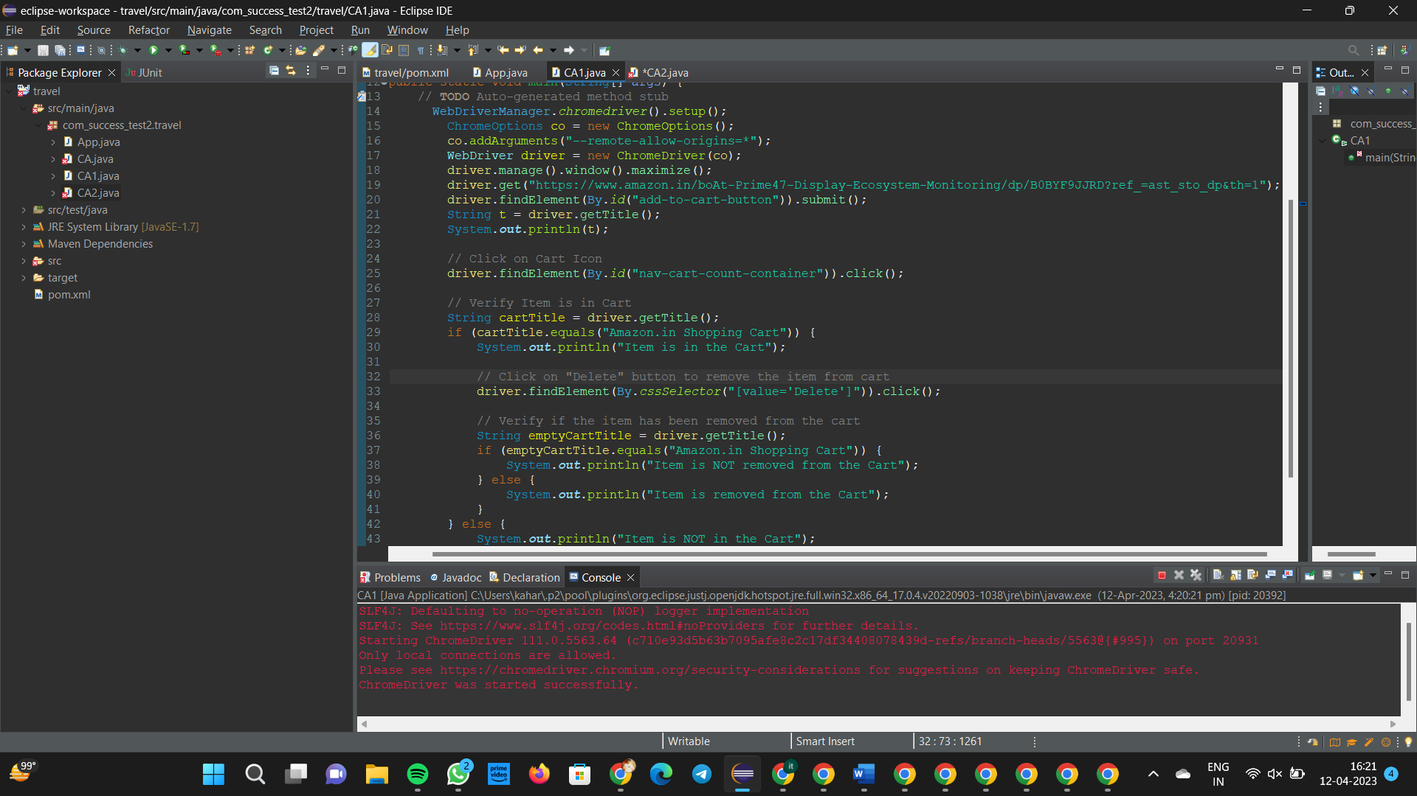

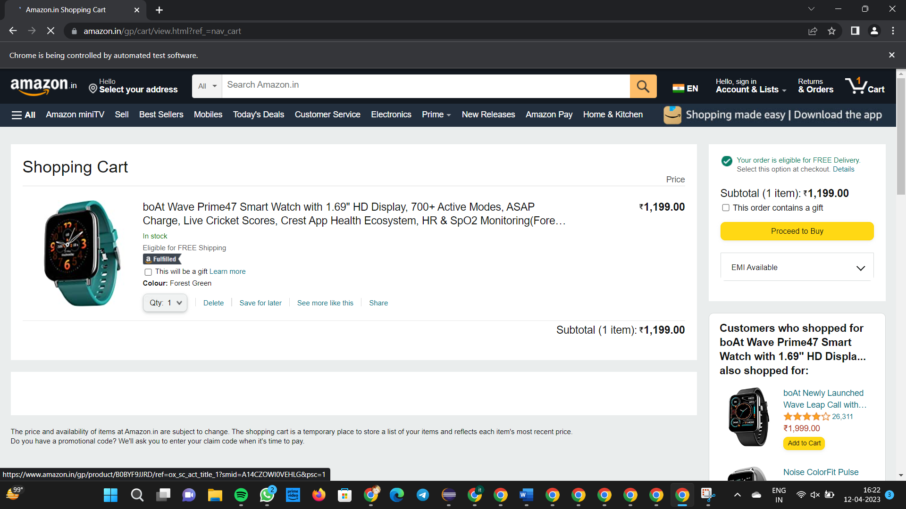

***REMOVE:***

***package com_success_test2.travel;***

import org.openqa.selenium.By;

import org.openqa.selenium.WebDriver;

import org.openqa.selenium.WebElement;

import org.openqa.selenium.chrome.ChromeDriver;

import org.openqa.selenium.chrome.ChromeOptions;

import io.github.bonigarcia.wdm.WebDriverManager;

public class CA2

{

public static void main( String[] args ) throws InterruptedException

{

WebDriverManager.chromedriver().setup();

ChromeOptions co=new ChromeOptions();

co.addArguments("--remote-allow-origins=*");

WebDriver driver=new ChromeDriver(co);

driver.manage().window().maximize();

driver.get("https://www.amazon.in/DR-VAKU-Adapter-Charger-

Black/dp/B09KN43PW1/ref=sr_1_1_sspa?crid=3GMJKRSPW2K0J&keywords=iphone+charger&qid=1681291277&sprefix=ip+hone+c%2Caps%2C432&sr=8-1-spons&sp_csd=d2lkZ2V0TmFtZT1zcF9hdGY&psc=1");

driver.findElement(By.id("add-to-cart-button")).submit();

driver.get("https://www.amazon.in/gp/cart/view.html?ref_=nav_cart");

driver.findElement(By.cssSelector("[value='Delete']")).click();

String t=driver.getTitle();

System.out.println(t);

    }

}

}***OUTPUT:***



2.)

***package com_success_test2.travel;***

import java.util.List;

import org.openqa.selenium.By;

import org.openqa.selenium.JavascriptExecutor;

import org.openqa.selenium.Keys;

import org.openqa.selenium.WebDriver;

import org.openqa.selenium.WebElement;

import org.openqa.selenium.chrome.ChromeDriver;

import org.openqa.selenium.chrome.ChromeOptions;

import org.openqa.selenium.support.ui.Select;

import io.github.bonigarcia.wdm.WebDriverManager;

public class App

{

public static void main( String[] args ) throws InterruptedException

{

WebDriverManager.chromedriver().setup();

ChromeOptions co = new ChromeOptions();

co.addArguments("--remote-allow-origins=*");

WebDriver driver=new ChromeDriver(co);

driver.get("https://www.amazon.in/DR-VAKU-Adapter-Charger-

Black/dp/B09KN43PW1/ref=sr_1_1_sspa?crid=3GMJKRSPW2K0J&keywords=iphone+charger&qid=1681291277&sprefix=ip+hone+c%2Caps%2C432&sr=8-1-spons&sp_csd=d2lkZ2V0TmFtZT1zcF9hdGY&psc=1");

driver.manage().window().maximize();

String title=driver.getTitle();

System.out.println(title);

if(title.equals("Online Shopping site in India: Shop Online for Mobiles, Books, Watches, Shoes and More - Amazon.in")) {

System.out.println("Verified title of the page");

}else {

System.out.println("Title not matched");

}

driver.findElement(By.id("twotabsearchtextbox")).sendKeys("phone");

driver.findElement(By.id("twotabsearchtextbox")).sendKeys(Keys.ENTER);

System.out.println("Searched Item successfully");

driver.findElement(By.id("a-autoid-0-announce")).click();

List<WebElement>li=driver.findElements(By.xpath("//*[@id=\"octopus-dlp-asin-stream\"]/ul/li[2]/span/div/div[2]/div[1]/a"));

for(WebElement link:li) {

System.out.println(link.getText());

}

System.out.println("User is able to filter by search");

System.out.println("Testing Ended");

driver.quit();

}

}

***OUTPUT:***

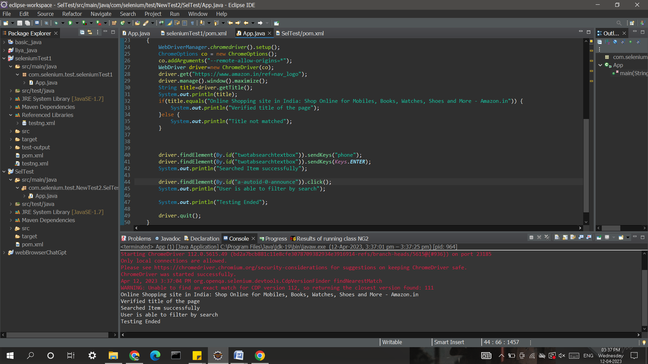

3.)

***package com_success_test2.travel;***

import java.util.List;

import org.openqa.selenium.By;

import org.openqa.selenium.JavascriptExecutor;

import org.openqa.selenium.Keys;

import org.openqa.selenium.WebDriver;

import org.openqa.selenium.WebElement;

import org.openqa.selenium.chrome.ChromeDriver;

import org.openqa.selenium.chrome.ChromeOptions;

import org.openqa.selenium.support.ui.Select;

import io.github.bonigarcia.wdm.WebDriverManager;

/**

* Hello world!

*

*/

public class App

{

public static void main( String[] args ) throws InterruptedException

{

WebDriverManager.chromedriver().setup();

ChromeOptions co = new ChromeOptions();

co.addArguments("--remote-allow-origins=*");

WebDriver driver=new ChromeDriver(co);

driver.get("https://www.amazon.in/ref=nav_logo");

driver.manage().window().maximize();

String title=driver.getTitle();

System.out.println(title);

if(title.equals("Online Shopping site in India: Shop Online for Mobiles, Books, Watches, Shoes and More - Amazon.in")) {

System.out.println("Verified title of the page");

}else {

System.out.println("Title not matched");

}

driver.findElement(By.id("nav-link-accountList")).click();

driver.findElement(By.id("ap_email")).sendKeys("HI28@gmail.com");

driver.findElement(By.id("ap_email")).sendKeys(Keys.ENTER);

driver.findElement(By.id("ap_password")).sendKeys("12342*");

driver.findElement(By.id("ap_password")).sendKeys(Keys.ENTER);

Thread.sleep(2000);

String name=driver.findElement(By.id("nav-link-accountList-nav-line-1")).getText();

if(name.equals("Hello, BOT")) {

System.out.println("Successfully, signed in");

}else {

System.out.println("Sign in failed");

}

System.out.println("Testing Ended");

driver.quit();

}

}

***OUTPUT:***

